BOULEVARD E ANITA
Immagine | Descrizione | Codice | Peso Kg | Dimensioni cm | Materiale | Quantità
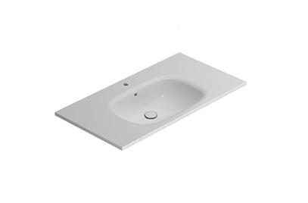 | Lavabo BOULEVARD 96.51  Lavabo 96.51 cm. Installazione sospesa o su base sospesa  Basin BOULEVARD 96.51  Basin 96.51 cm. Wall-hung installation or on wall-hung cabinet | BL096BI  BL096XX  BL096BI  BL096XX | 26 | 96x51 h18 | Fire Clay
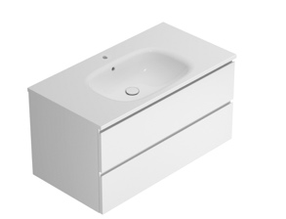 | Base sospesa BOULEVARD 95.50,5  Base sospesa 95.50,5 cm. Con 2 cassetti  Wall-hung cabinet BOULEVARD 95.50,5  Wall-hung cabinet 95.50,5 cm. With two drawers | BL010XX  BL010XX | 36 | 95x50,5 h49
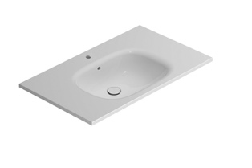 | Lavabo BOULEVARD 86.51  Lavabo 86.51 cm. Installazione sospesa o su base sospesa  Basin BOULEVARD 86.51  Basin 86.51 cm. Wall-hung installation or on wall-hung cabinet | BL086BI  BL086XX  BL086BI  BL086XX | 23 | 86x51 h18 | Fire Clay
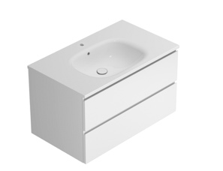 | Base sospesa BOULEVARD 85.50,5  Base sospesa 85.50,5 cm. Con 2 cassetti  Wall-hung cabinet BOULEVARD 85.50,5  Wall-hung cabinet 85.50,5 cm. With two drawers | BL011XX  BL011XX | 33 | 85x50,5 h49
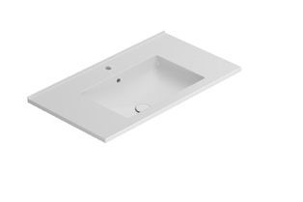 | Lavabo ANITA 81.46  Lavabo 81.46 cm. Installazione sospesa o su base sospesa  Basin ANITA 81.46  Basin 81.46 cm. Wall-hung installation or on wall-hung cabinet | HA081BI  HA081BO  HA081BI  HA081BO | 23 | 81.46 h16,5 | Fire Clay
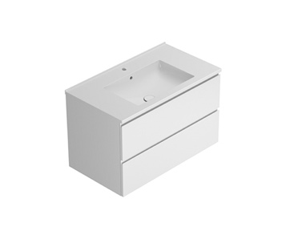 | Base sospesa ANITA 80.45  Base sospesa 80.45 cm. Con 2 cassetti  Wall-hung cabinet ANITA 80.45  Wall-hung cabinet 80.45 cm. With two drawers | HA010XX  HA010XX | 28 | 80x45 h49
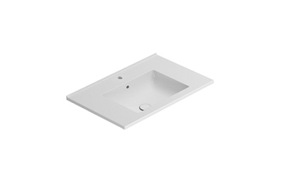 | Lavabo ANITA 71.46  Lavabo 71.46 cm. Installazione sospesa o su base sospesa  Basin ANITA 71.46  Basin 71.46 cm. Wall-hung installation or on wall-hung cabinet | HA071BI  HA071BO  HA071BI  HA071BO | 21 | 71x46 h16,5 | Fire Clay
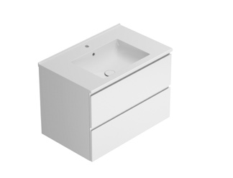 | Base sospesa ANITA 70.45  Base sospesa 70.45 cm. Con 2 cassetti  Wall-hung cabinet ANITA 70.45  Wall-hung cabinet 70.45 cm. With two drawers | HA011XX  HA011XX | 29 | 70x45 h49
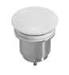 | Piletta in ceramica Up&Down  Piletta up & down con tappo in ceramica  Push open valve drain with ceramic top  Push open valve drain with ceramic top | FI012BI  FI012XX  FI012BI  FI012XX | 0,5
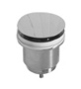 | Piletta cromata Up&Down  Piletta up & down con tappo cromato  Push open chromed valve drain  Push open chromed valve drain | FI012CR  FI012CR | 0,5

